**PESS: Personal Emergency Safety Shield**

**Abstract:**

The PESS (Personal Emergency Safety Shield) Android application is a comprehensive solution designed to enhance women's safety. The app incorporates a range of features that allow users to quickly and discreetly alert emergency contacts in case of danger and report incidents. PESS aims to empower women and promote a safer environment for them by leveraging the power of technology and community support.

**Introduction:**

The safety and security of women have become a significant concern in today's world. Numerous instances of harassment, assault, and violence against women emphasize the need for an effective safety solution. PESS is an Android application that addresses this issue by providing a platform where women can access tools and resources to ensure their safety.

**Problem Statement:**

The prevalence of gender-based violence and the lack of accessible and efficient safety solutions for women in emergency situations have highlighted the need for a comprehensive safety application. PESS aims to bridge this gap by providing a user-friendly and effective solution that caters to the specific needs of women.

1

**Idea Description:**

PESS is an Android application that offers a set of features designed to enhance women's safety. These features include:

1

**1.SOS Alert:** Users can send distress signals to their emergency contacts with just a single tap on the PANIC button.

**2.Current Location:** The message that will be sent to the emergency contacts will provide users’ current location (you can search on google map).Which will help users’ family/friends to find her and send help quickly.

**3.Phone Shaking:** Emergency Message can also be sent by just shaking your android device.

**Project Features:**

**1.User Profile:** Users can create and manage their profiles with personal and emergency contact information.

**2.Emergency Contacts:** Users can add multiple emergency contacts.

**3.Real-time Location Sharing:** Share real-time location with trusted contacts.

**4.PANIC Button:** A panic button is added to the home interface. Users can push the panic button in time of emergency.

**4.Privacy Protection:** User data is secured and only shared when an SOS alert is triggered.

**5.Accessibility Features:** PESS is designed with user accessibility in mind, ensuring it's easy to use for all.

2

**6.ShakeDetector:** Phone shake detector is placed in the welcome interface. After opening the app, user can shake the phone and an automatic message will be sent to the emergency contacts.

**Project Timeline:**

The project was developed in several stages:

**1.Project Initiation and Planning:** Defining project goals, requirements, and team roles.

**2.Design and Prototyping:** Creating wireframes and mockups of the application.

**3.Development:** Building the Android application using Java.

**4.Testing and Quality Assurance:** Extensive testing to ensure functionality and security.

**Target Population:**

PESS primarily targets women, but its features are available to anyone who seeks personal safety and community support. The app is especially beneficial for women of all ages and backgrounds, providing them with a reliable tool to enhance their safety.

**Social and Emotional Value:**

PESS aims to create a safer environment for women and empower them to take control of their safety. It offers emotional support, ensuring that users do not feel alone when facing challenges.

3

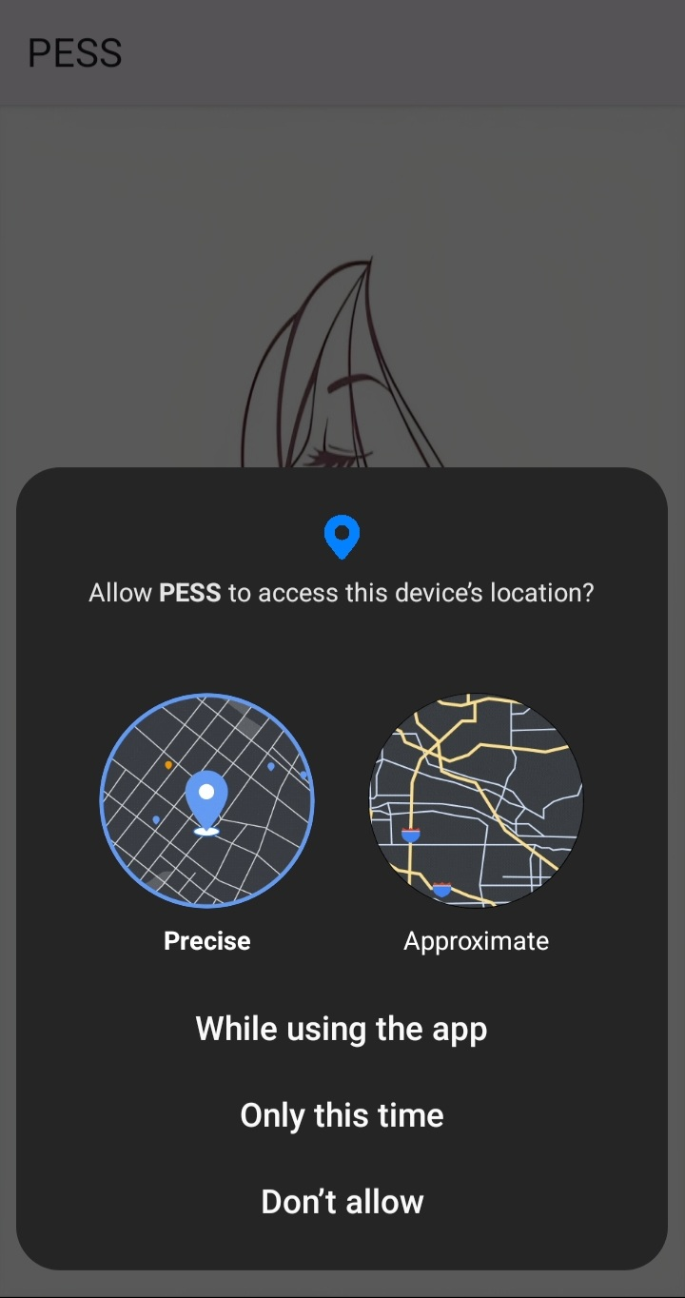**Project Screenshot**:

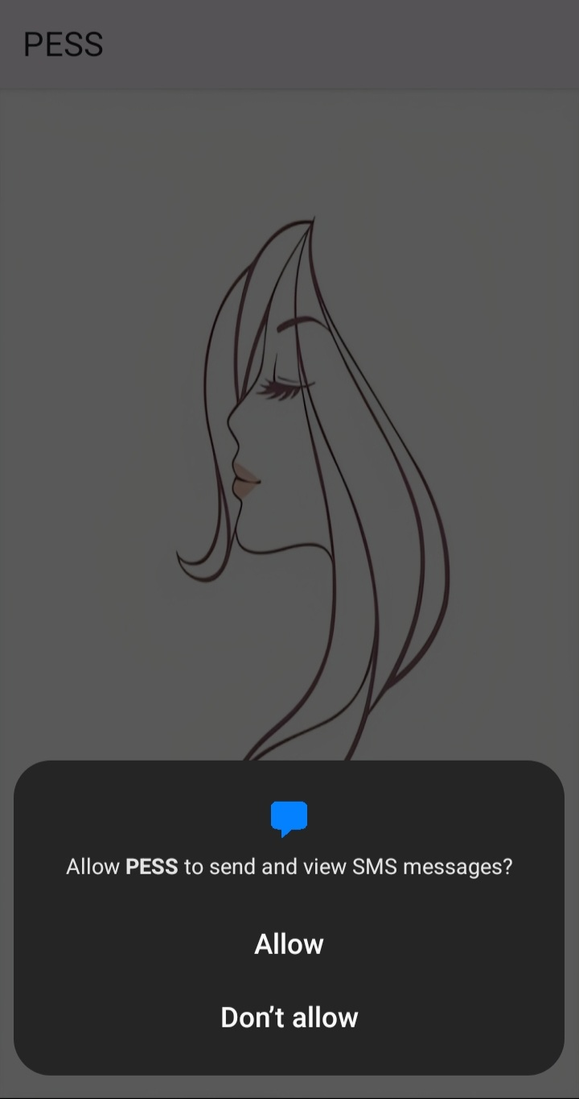**Fig.1:** After opening the app, the first thing the app will ask for is, to access the device’s location.

**Fig.2:** Permission to send SMS.

4

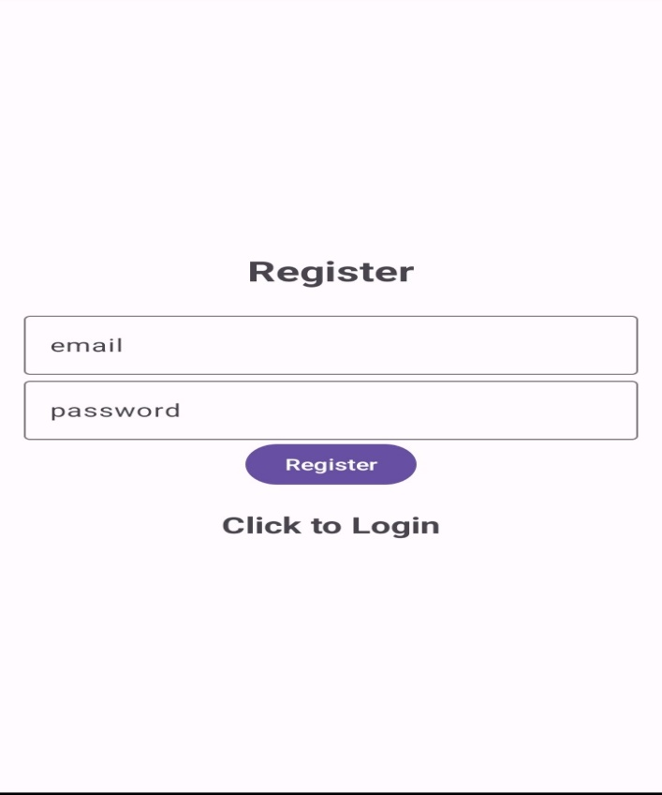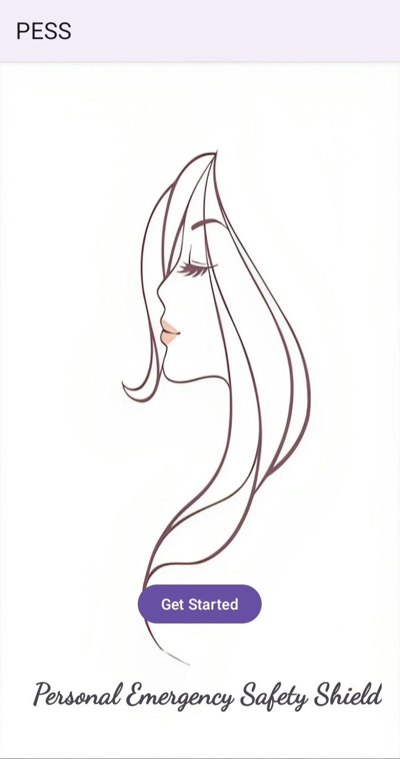 **Fig.3:** Welcome Interface.

**Fig.4:** Register Interface, user will register her email and password.

5

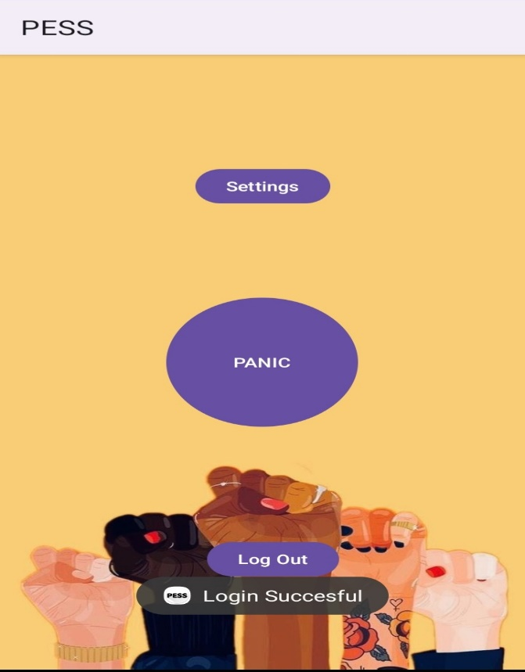 **Fig.5:**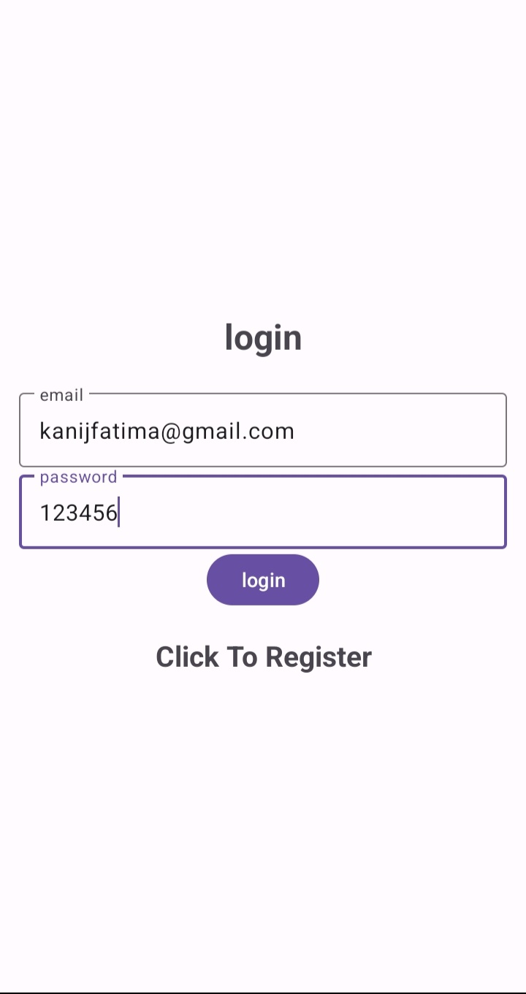 log in with your registered email and password.

**Fig.6:** HOME interface with PANIC button and settings button.

6

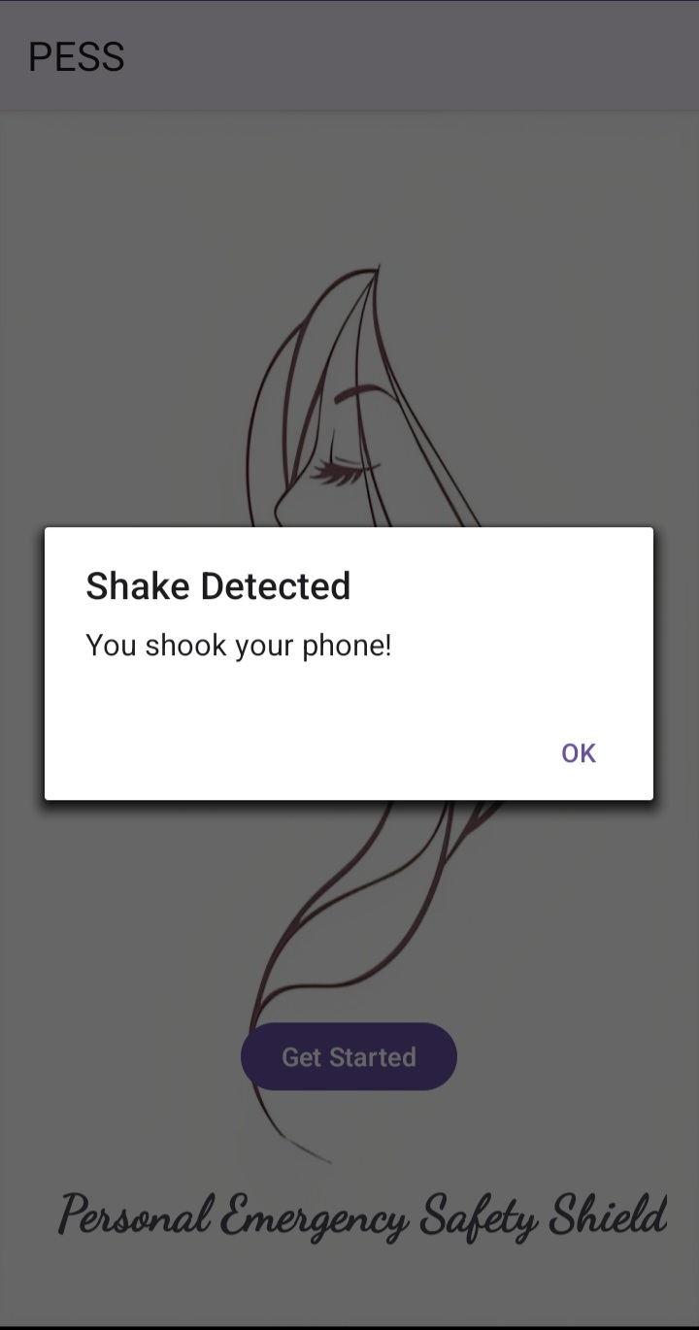**Fig.7: 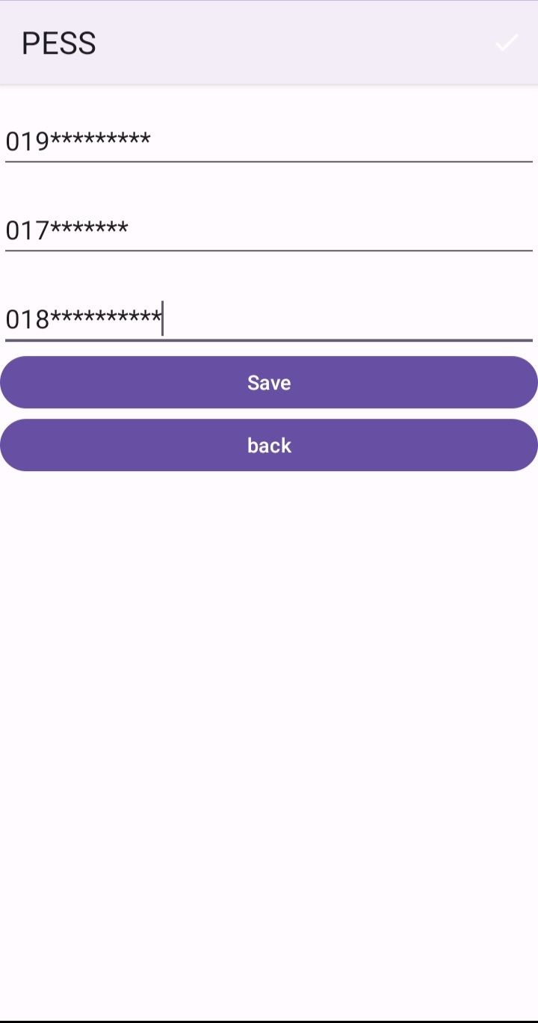**After clicking the SEETINGS button in previous interface, insert some emergency phone numbers here.

**Fig.8:** Open the app and simply shake your phone from right to left to send emergency message.

7

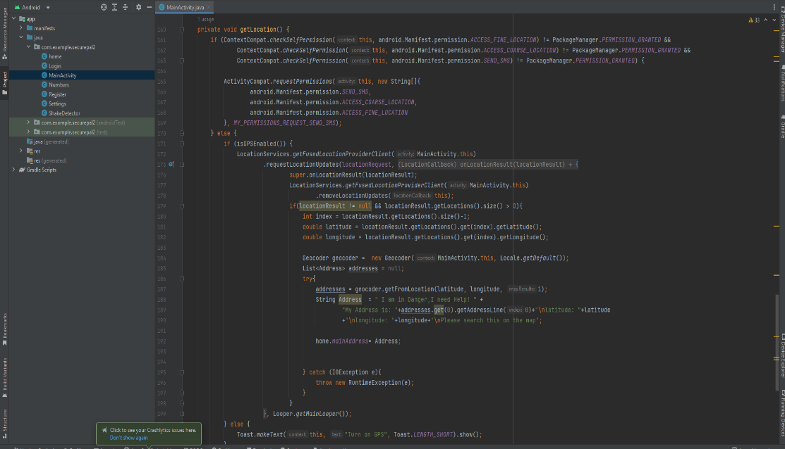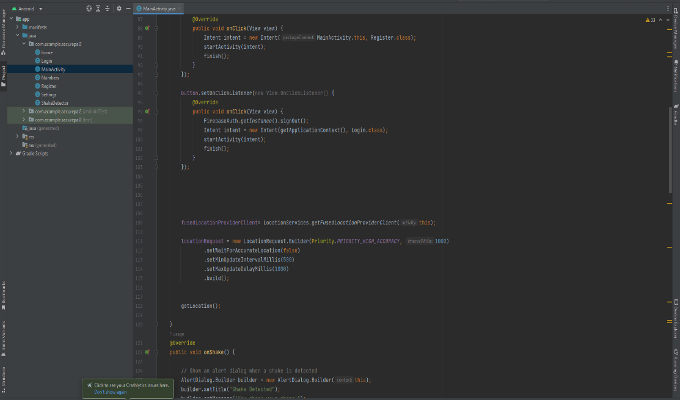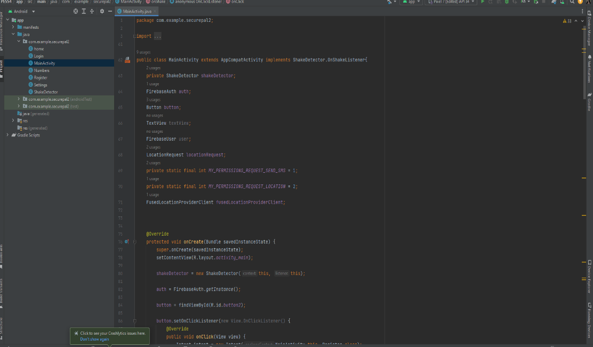**Source Code:**

9

9

8

Fig: Main Activity Code (partial).

**Conclusion:**

PESS is a significant step towards addressing the safety concerns of women in today's world. By providing a comprehensive range of features, the application empowers users to take control of their safety. It also promotes a sense of community support, ensuring that women do not feel isolated in their efforts to stay safe.

**Acknowledgment:**

We would like to express our gratitude to advisors, course teacher and users who contributed to the development and improvement of PESS.

**References:**

https://github.com/Kanijhere/PESS-women-safety-application-.git

9